- Implement a producer-consumer communication system using anonymous pipes where the parent process generates data and the child process consumes it. Measure the communication efficiency.
Develop a program that executes the equivalent of the shell command: ls -l | grep ".c" using fork(), pipe(), dup2(), and exec() system calls.

OUTPUT :
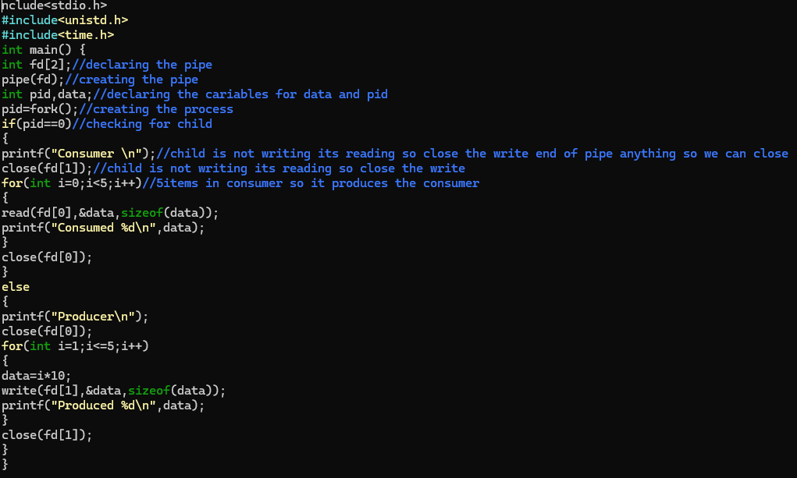

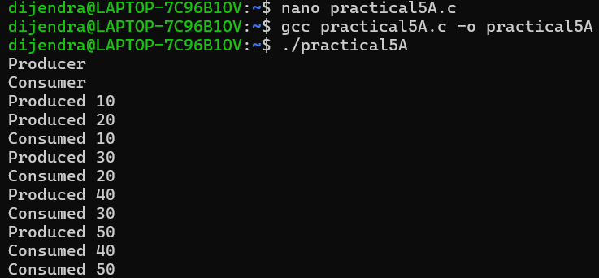

5(B) :
OUTPUT :
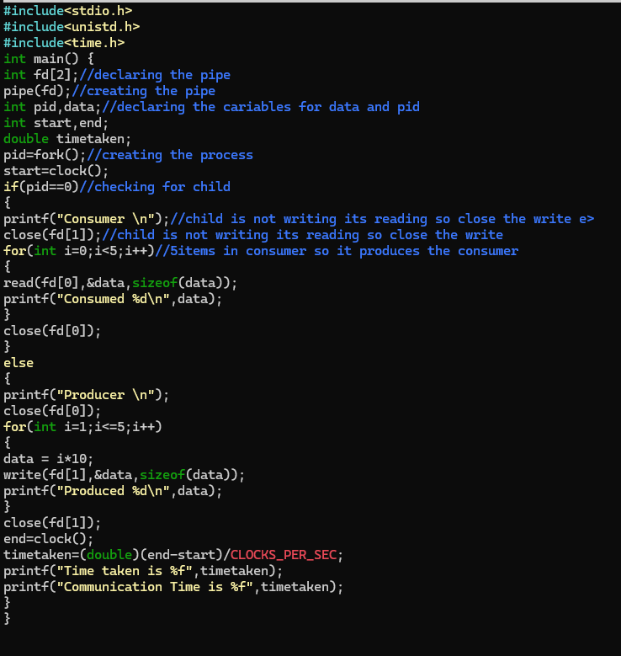

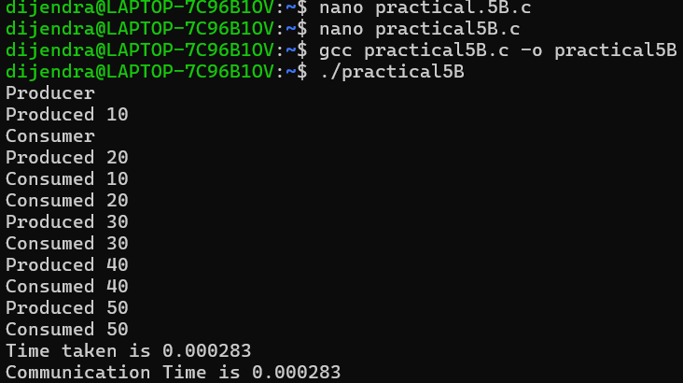
5(C) :
OUTPUT :
